Free Education: Wet Dream or Revolution?
(Free Education talk at SANE 2006 conference, Aula Congress Centre, Delft, The Netherlands by Wiebe van der Worp, Vrijschrift.org Foundation)

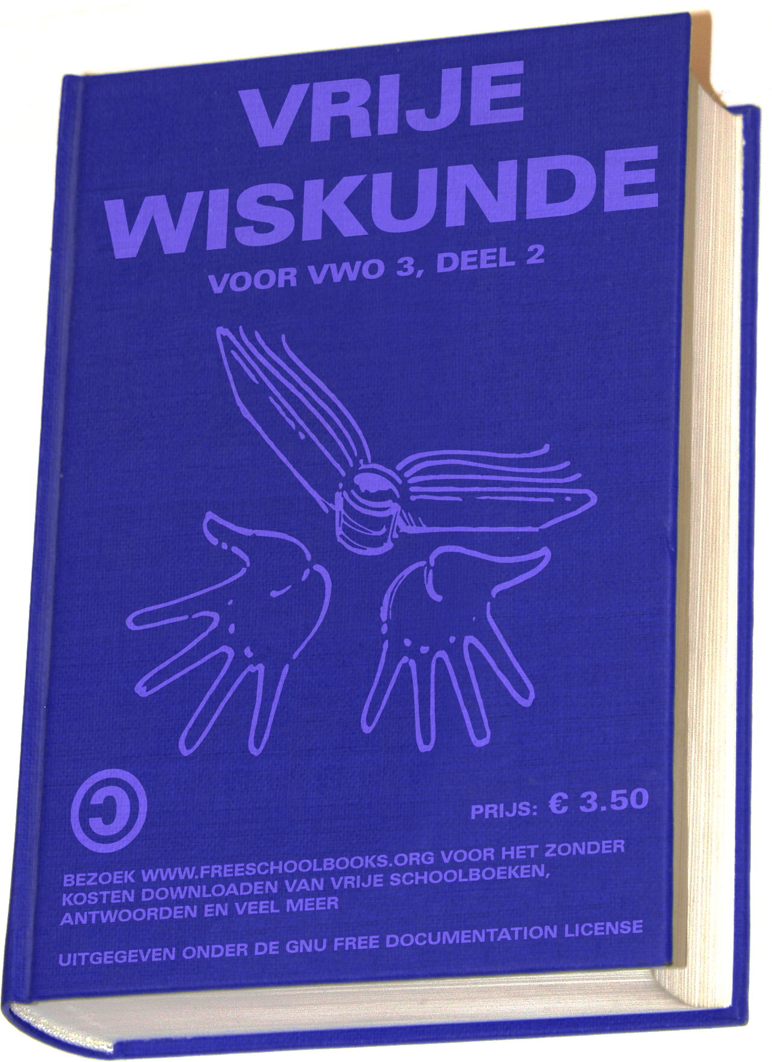
What are Free Schoolbooks?
This one is easy to understand for this smart audience. Compare Free Schoolbooks to Free Software: simply apply a Free Documentation License to a schoolbook instead of a GPL and you understand the idea of having the freedoms to copy, study, improve and distribute them. Instead of writing if, then, else statements you write down text. Instead of designing menu's you'll add illustrations and a table of contents. It is all the same principle.
The concept is not new, there are already Free Schoolbooks in use, but their quantity is low and often the quality too.
In 2001 several experts said Wikipedia was bound to fail. Who would be interested to fill the library based on a Free Documentation License while everybody is able to destroy pages? Four years later Wikipedia became the largest encyclopedia on earth.
Well, I can't think of an argument why Free Schoolbooks wouldn't be as successful. Its stakeholders are probably even more motivated:
- Teachers: a motivated group (by the way, we see many of them involved in Project Gutenberg and Wikipedia). Teachers have a direct interest in the best possible books.
- Students (of course!): if they say books are boring and sucking they are free to participate and change it according to their needs.
- Parents: they simply want the best for their kids. They also have a broad variety of handy skills, for example making illustrations.

What is the impact on society?
The power of Free information is in the license and Free Schoolbooks on the net result in unhindered access to educational sources which in its turn results in economic growth en more prosperity.
From an international point of view Free Education is an excellent way to end starvation and poverty by developing the third world. There is an extra condition: we should allow them to take part in out economic monopoly game!
Access to free knowledge is the best way to fight ignorance, extremism and discrimination of women and races. Finally Free Education is the only way to fight terrorism.

Closing the cultural gap
There is a huge gap between our free culture and the world of education. Our more academic culture is characterized by rapid changes and development. For publishers fair competition is a dirty word. As a result the education society has adapted itself to the publishers. It is a world of minor changes and they are forced to lean against far from innovative publishers. By the way, this is one of the causes why free software is hard to introduce at schools.
So making books with an alternative license is quite shocking for them. It is almost impossible to explain why freedom is important and make this group aware. Have you never noticed that it is even hard to explain it to your own mother?
An important conclusion can be drawn: take care of a simple solution, just books in a patent free and proper format is what is needed in first instance. Forget talking about systems based on micro content, on the fly publishing and other advanced systems. So many e-learning projects failed completely that we must take our lessons.
For us Free Education is a logical next step of our free culture. But for the rest of the world it is a revolutionary concept and please, don't forget the old arguments against Free Software: not mature, for geeks, no support, a bad commercial model that simply cannot work.
For Free Education we have to prove again that these arguments are nonsense and I can predict already that we'll have to fight against publishers spreading FUD. History recalls.

An example
Third grade secondary education (VWO): 28,000 students in the Netherlands, price of math books for one year: Eu 82.-

Time line
- The idea of applying a GPL to products other than software - like mechanical engineering and schoolbooks started started somewhere in 1998.
- Together with FSF-Europe and other organizations a request for funding by the Commission's e-learning program was done in 2003 and was not rewarded. This was the first disappointment.
- Former Secretary of State Annette Nijs made an appointment in 2004 (she approached us, we didn't even ask for it!) but her successor Rutte waived the appointment.
- In 2005 we've asked for help from the Dutch Ministry of Education: we never got answers.
- Jan Marijnissen from the Dutch Socialists Party launched a plan in 2005 to lower prices of schoolbooks. At some points it was close to our approach (schools should develop books in private). So far there is no political willingness to pick it up.
- In 2006, a recent letter to the Dutch Minister of Education with the question what to answer here tonight is not answered yet.

Some points
- Governments should support schoolbook projects. They can play a role of catalyst and the community can pick the fruits sooner.
- To start a complete pilot project is needed, focused on a usable end product. It is no problem to involve payed project members giving it more momentum, this can solve the problem of projects being to informal and finally dying.
- For publishers it is not the end of the world, let them take a look at O'Reilly.
- International cooperation is a must. Think about sharing illustrations and exercises, about checking an English course by native speakers. Our power is reusing information and standing on shoulders.
- We need project forges for this non software product.
- Non free standards like .doc are out of the question.

Finally
We have 4 million students in the Netherlands. Together they spend € 700,000,000 on schoolbooks every year. In our small country with 16 million citizens one may say that every citizen pays every year an average of € 40 on schoolbooks. Feel free to re-calculate it for your country. Reducing this amount means better ways to spend money, more prosperity and education available for everybody. It is a dream that can be turned into a true revolution. Like every evolution it is going to take some time. But the quicker we seed the quicker we can harvest. I am convinced that we can be more successful when governments want to help doing a serious pilot, while being patience because it takes years to build a contributing community of teachers, parents and students. Despite a disappointing attitude of the European Commission and Dutch politicians we have to keep putting this subject under the attention and your help is needed.

How you can make a difference
Visit http://www.vrijschrift.org/vrijleren/ and join the Dutch or international mail list:
- http://mailman.vrijschrift.org/listinfo/vrijleren
- http://mailman.vrijschrift.org/listinfo/freelearning

